Virtual Lab 4 – Impedance Matching and Smith Charts

Pre-Laboratory
Understand impedance matching using quarter-wavelength transformer and single stub.

When you simulate a frequency sweep, use “fast sweep” option and set the frequency step to be small, i.e. 0.01 GHz in order to achieve a smooth curve for S Parameters.

Part 1 Quarter-wavelength Transformer Matching

- Create a junction between two microstrip lines. Specify the structure as following:
Ground Plane: Perfect Conductor
50 mm long (x-direction)
30 mm wide (y-direction)
17 μm tall (z-direction)

Substrate: Teflon (ε_{r} = 2.1)
Same as ground plane in x and y directions
2 mm tall
Placed on the ground plane

Air: Same as ground plane and substrate in x and y
9.5 mm tall
Position at 0, 0, 0

Input Microstrip: Perfect Conductor
25 mm long (x-direction)
2 mm wide (y-direction)
17 μm tall

Output Microstrip: Perfect Conductor
25 mm long (x-direction)
10 mm wide (y-direction)
17 μm tall

Your finished structure should resemble that in Figure 1.

- Create ports at the ends of the microstrip lines. To draw the ports, use Lines/Rectangle in the 3D Modeler. Enter (x, y, z) = (50, 7.5, 0.017) as the first point of the rectangle, and let the width in the y-direction be 15 mm and the height, in the z-direction, be 7.5 mm. Draw an identical port on the output end of the structure. Define these to be ports in the excitations. Let all other surfaces be Perfect E boundaries (by default). (This is equivalent to putting the whole structure in a metal box.)

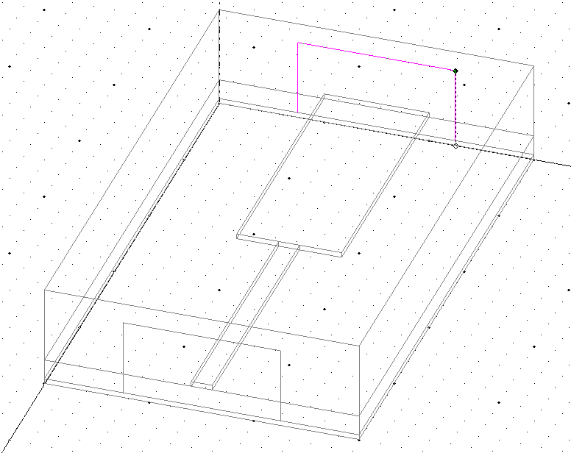
Figure 1 Microstrip Transmission Line Junction (quarter-wave transformer not shown)

- Run a simulation for this structure at 12 GHz. You do not need to run a sweep for now. Max Delta S = 0.02 and # of passes = 8 should be sufficient.

- Design a quarter-wavelength transformer at 12 GHz and insert it in between the two microstrip lines. Let the transformer be a perfect conductor and use 17 μm for the thickness. Your final structure should look similar to that in Figure 3. Note that the dimensions for the transformer in this figure are illustration only.

- When you insert the transformer, do not increase the overall size of the structure. Adjust the lengths of the two microstrip lines such that the quarter wave transformer is roughly centered in the x-direction.

- You may find it useful to perform a Port Only solution in order to obtain the characteristic impedance of a microstrip line. The Port Only solution only simulates the cross section of the microstrip line at the port and then provides the characteristic impedance and guided wavelength. The port only solution is set up as shown in Figure 2. The Port Only simulation takes just a few seconds. The most convenient way is that you create a new project in HFSS with one microstrip line only. You can find the characteristic impedance of a microstrip line by simply modifying the width of the microstrip line.

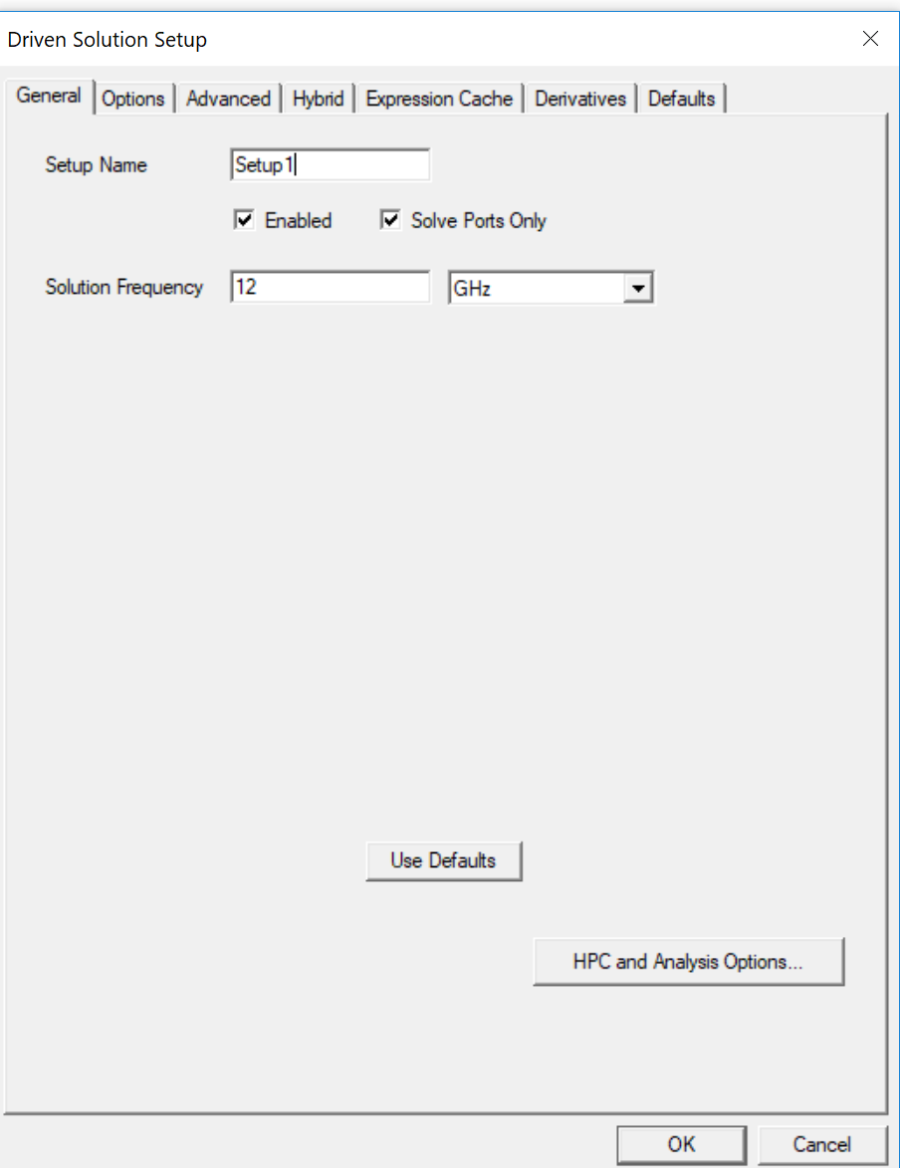
Figure 2 Illustration of the Setup for a Ports Only Solution

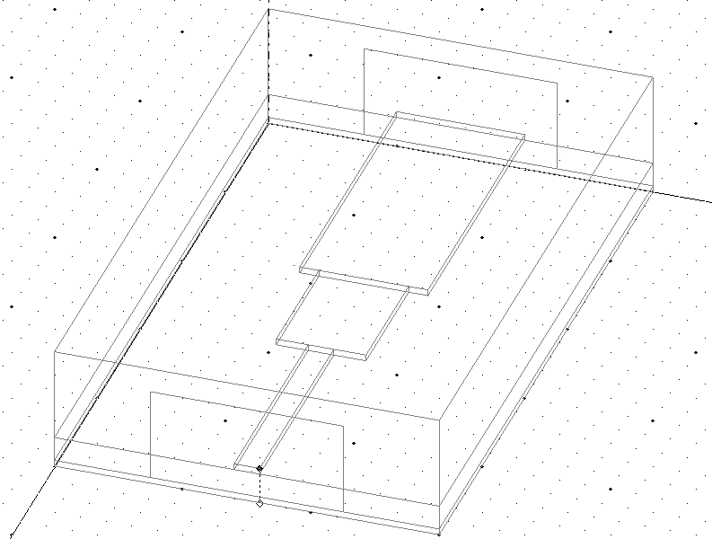
Figure 3 Quarter-wavelength Transformer (Note that this transformer does not have the correct dimensions)

- Run the simulation of the structure in Figure 3 at 12 GHz, and include a sweep from 8-16 GHz. Start with a Max Delta S = 0.02 and record of the number of passes in this simulation. If you are not certain if the solution is converged or not. Set Max Delta S = 0.002 and increase the # of passes by 2 from your recorded # of passes. Compare the S parameters of these two cases. If they are very close to each other, your simulation is converged. If not, repeat the process once more until the results are converged.

Part 2 Single-Stub Matching

- Create a junction between two microstrip transmission lines. Specify the structure as following:
Ground Plane: Perfect Conductor
50 mm long (x-direction)
40 mm wide (y-direction)
17 μm tall (z-direction)

Substrate: Teflon (ε_{r} = 2.1)
Same as ground plane in x and y directions
2 mm tall
Placed on the ground plane

Air: Same as ground plane and substrate in x and y
9.5 mm tall
Position at 0,0,0

Input Microstrip: Perfect Conductor
40 mm long (x-direction)
4.5 mm wide (y-direction)
17 μm tall

Output Microstrip: Perfect Conductor
10 mm long (x-direction)
1 mm wide (y-direction)
17 μm tall

Your finished structure should resemble that in Figure 4.

- Create ports at the ends of the microstrip lines just as in part 1. To do this, use Lines/Rectangle in the 3D Modeler. Enter (x, y, z) = (50, 7.5, 0.017) as the first point of the rectangle, and let the width in the y-direction be 15 mm and the height, in the z-direction, be 7.5 mm. Draw an identical port on the output end of the structure. Your ports should resemble those shown in Figure 4.

- Run a simulation at 5 GHz for this structure. You do not need to run a sweep for now.
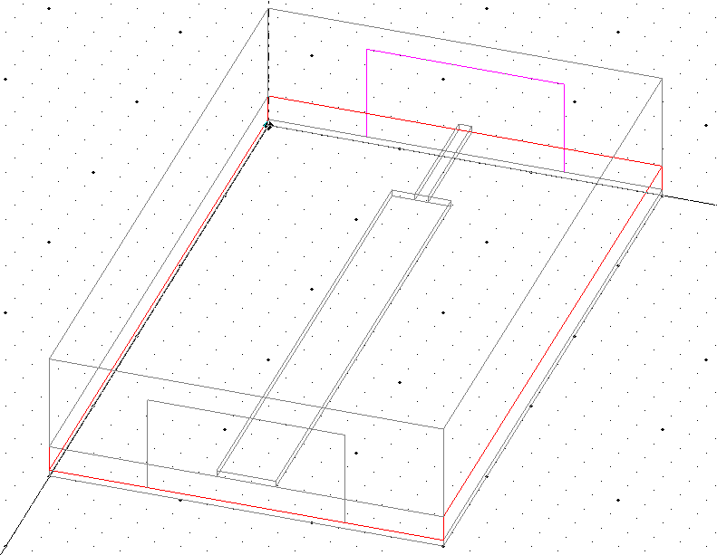
Figure 4 Details of Microstrip Junction Structure (matching stub not shown)

- Design a single stub matching network at 5 GHz using an open-ended shunt microstrip line with a width of 4.5 mm. Determine the location where the stub meets the main microstrip line and its length. The final structure should look like what is shown in Figure 5. If the end of the stub is too close to the edge of the box, you may slightly increase the size of the box in y-direction. There might be multiple solutions. Choose the one which provides the widest bandwidth. You must show the design procedure on a Smith Chart.
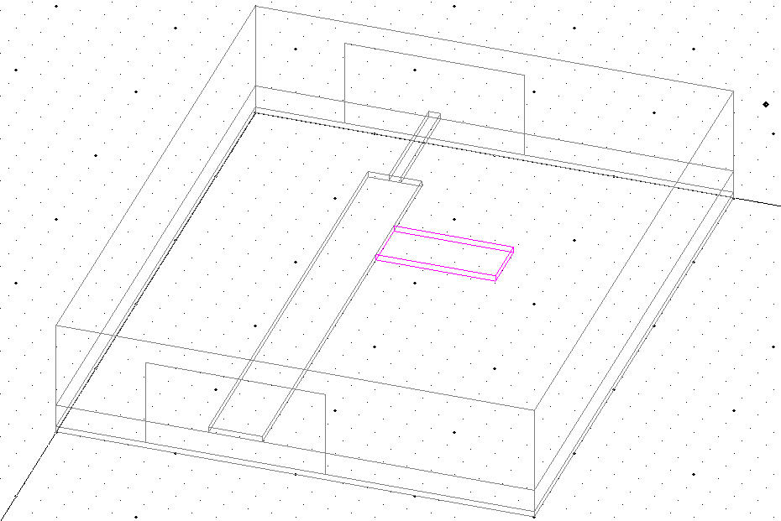
Figure 5 Microstrip Junction with a shunt Stub (stub location and length are illustration only)

- Run a simulation at 5 GHz. Also, run a sweep from 2-8 GHz to test the frequency dependence of your matching stub. Check the convergence in the same way as described earlier.

Lab report

Quarter-Wavelength Transformer

- (5 pts) Plot the S-parameters for the structure without the quarter-wavelength transformer. (You must run a sweep to plot the S-parameters)
- (10 pts) List the dimensions of your quarter-wavelength transformer. Show a screen capture of the final structure with the quarter-wavelength transformer.
- (10 pts) Plot the S-parameter for the structure with the quarter-wavelength transformer.
- (5 pts) Does the best matching occur at 12 GHz? If not, what is the reason?
- (5 pts) What is the reflection coefficient at 12 GHz? What is the SWR at 12 GHz?
- (5 pts) You might see a peak in S11 within the matching bandwidth which is unexpected. This is called box resonance. How do you remove it by explaining? (10 pts) Prove your method by doing another HFSS simulation.
- (5 pts) Does the quarter-wave transformer work in the reverse direction? That is, if port 2 is the input port, is the impedance matching still achieved?
- (5 pts) Show a screen capture of the mesh in both air and substrate region. Which region has a denser mesh? What is the reason?

Single-Stub Matching Network

- (5 pts) Plot the S-parameters for the structure without the single stub matching.
- (20 pts) Show all your design steps and details on the Smith Chart. For your final design, what is the distance from the impedance mismatch to the nearest edge of the stub? What is the length of the stub? Show a screen capture of your final design.
- (10 pts) Plot the S-parameters for the structure with the single-stub matching network.
- (10 pts) Does the best matching occur at 5 GHz? If not, what is the reason?
- (5 pts) Does the single stub match work in the reverse direction?

